Bjuder in till 2-dagars kurs
”The Sporting Shoulder”
Advanced level
15-16 februari 2020
Edel Fanning från SSC Sports Medicine, Dublin (Enda Kings kollega) kommer tillbaka och håller en mycket uppskattad axelkurs här på Idrottskliniken!
The course includes assessment and treatment of the Sporting Shoulder.
A large component will be practical and will give you competence in assessment, exercise selection, execution and progression: control, strength, reactive strength & power and return to play/phased contact drills.
Edel combines evidence based principles with a step by step exercise approach that will give you an effective shoulder rehabilitation program to meet your client’s needs!

Kostnad: 5 200:- + moms, anmälan är bindande.
Plats: Idrottskliniken Rehab, Vintervägen 50 A, Solna.
Lunch, för- och eftermiddagsfika ingår.
Begränsat antal platser.
Anmälan med namn, e-mail och mobilnummer till:
reception@idrottsklinikenrehab.se

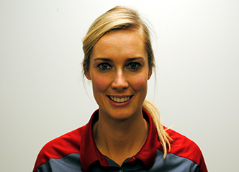
Edel Fanning, Msc. Adv MSK Physio, MMACP, M.I.S.C.P
Edel is Shoulder Specialist physiotherapist and leads the upper limb rehabilitation service at the SSC, Dublin. She has presented at national and international conferences on rehabilitation of the shoulder. Edel has a keen interest in shoulder biomechanics, the sporting shoulder and injury prevention and works with elite athletes from a wide range of sporting disciplines. She is now completing her PhD at the University College Cork investigating the use of return to play criteria post glenohumeral joint stabilisation. Her work explores 3D biomechanics and the use of novel upper limb functional tests in assisting return to play decision making post shoulder reconstruction in contact athletes. ​

